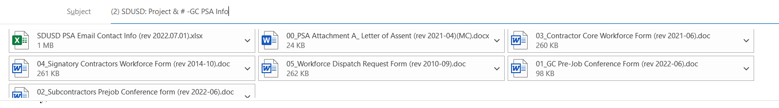
(2) SDUSD: Project & # -GC PSA Info – GC required Documents
Good afternoon Contact,

Congratulations on the award of the Project – contract#.

As we begin to get set up for the Pre-Job Meeting scheduled for Day, Month 00, 2022 at xx:xx am/pm, please review the following information for PSA expectations and details regarding PSA forms.

Pre-Job Mtg. Set-up: 1. Date & time is identified, a Zoom webinar invite can be set up.
2. Zoom link will be sent to you and your management team as a “panelist” for the meeting. NOTE: this link should not be shared with anyone. 3. Separate link will be sent to your subcontractor(s) as a general attendee.

- The District, general contractor, and all known subcontractors (regardless of tier-level), are required by PSA Articles 8 and 16 to conduct and attend a PSA Pre-job Meeting with the local construction trade unions. Our office will assist you with this process and ensure you are prepared for the meeting.

Responsibility of Contractor Name., the General Contractor (GC), to ensure that the PSA documents (forms attached or in PSA Application) are complete (in full) and submit by all contractors covered by this agreement to the District and appropriate Union(s) prior to performing any labor (Section 2.6-b).
- New Project -1st. Pre-Job Mtg. – GC will need to send list of all subcontractors for PSA App. invitations to complete Pre-Job Form & submit to Specialist to be published for Pre-Job Mtg.
  - Tiered Subcontractors – invites be sent to tiered subcontractors by the Specialist when listed on form
  - Letter of Assents will still be required for Cloud upload

PSA CLOUD site where the PSA project information is available for review:
http://fpcprojects.sandi.net/sites/PSA
You can also click here to access the SDUSD PSA information page to view the full PSA agreement, amendments, documents/forms, and additional information.

GC’s must have pre-job forms (Letter of Assent and Pre-Job forms with work assignments) to our office no later than 7 days prior to the Pre-Job Meeting. This time frame allows sufficient time for our office to upload the documents to the CLOUD site. Please forward these documents to me for review when they have been completed.

Please note that preconstruction activities also covered under this agreement include trailer set up -temp power, plumbing, and any additional built on items not attached or prefab’ed prior to delivery (stairs/decks/shade/storage).

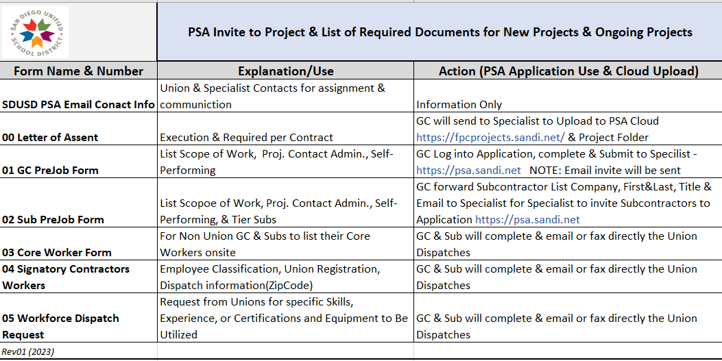
The below information is a quick review/summary of related excerpt from the full PSA, as well as details on documents needed to meet PSA compliance.

ARTICLE II SCOPE OF THE AGREEMENT
Section 2.4 Awarding of Contracts
(b) It is agreed that all Contractors and Subcontractors of whatever tier, who have been awarded contracts for Covered Work by this Agreement, shall be required to accept and be bound by the terms and conditions of this Agreement, and shall evidence their acceptance by the execution of the Agreement or of the Letter of Assent as set forth in Attachment A hereto, prior to the commencement of work. No Contractor or Subcontractor shall commence Project Work without first providing a copy of the Agreement or Letter of Assent as executed by it to the Project Labor Coordinator (PSA Coordination Team).

Letter of Assent (LOA): All contractors (regardless of tier) performing covered site work, shall execute (sign) the LOA and provide copies to the General Contractor and PSA Coordination Team. We ask that this letter be on company letter head whenever possible. (Section 2.4-b)

ARTICLE VIII WORK ASSIGNMENTS AND JURISDICTIONAL DISPUTES
Section 8.5 Pre-job Conference
In order to avoid jurisdictional disputes, a pre-job conference is required be held prior to the start of work by any contractor for projects covered by this Agreement. The purpose of the conference will be to, among other things, determine craft and manpower needs as well as the schedule of work for the job site.

The following forms will be required to ensure compliance:

Core Workforce Form: All Non-Union subcontractors are to complete this form for their Core Employees & submit directly to the Union
- This form is required to be sent to each appropriate Union prior (no less than 48 hours) to any contractors binging labor force onsite/to beginning project work
- 3-workers per ratio: 1st, 3rd, and 5th workers contractors “core” employee; 2nd, 4th, 6th+ Union dispatched worker

Signatory Workforce Form: All Union subcontractors are to complete this form for all employees performing site work. Submit directly to the Union
- This form is required to be sent to each appropriate Union prior (no less than 48 hours) to any contractors binging labor force onsite/to beginning project work

Request for Dispatch Workforce Form: All Non-Union subcontractors are to complete a request for dispatch form, per Union assignment, for the dispatch of Union member employee. Submit directly to the Union
- This form is required to be sent to each appropriate Union prior (no less than 48 hours) to any contractors binging labor force onsite/to beginning project work
- 3-workers per ratio: 1st, 3rd, and 5th workers contractors “core” employee; 2nd, 4th, 6th+ Union dispatched worker

Self – Certification Form: Completed by all subcontractors, regardless of signatory or non-signatory status, and returned to the Districts Outreach Manager Alma Banuelos (abanuelos@sandi.net) for small business.

Please note: if your employees are not current and actively registered with the Union, they will need to do so prior to performing covered work onsite to avoid being out of compliance, delays, or grievances. Likewise, all employee benefits are required to be submitted, will need to be set up with the appropriate Trust, and paid to said Trust monthly (Section 2.6-b); to be in compliance.

The link provided here, PSA Required Documents (Core, Signatory & Dispatch), will also take you to uploaded copies of the Executed Project Stabilization Agreement and all Addendum to it which cover the extension of the PSA to additional props, bonds, and measures. This location also houses the PSA required documents and additional District information.

An official “Welcome” letter will be coming within the next couple of days. Our goal is to provide helpful information for a smooth transition into construction; however, should you have any additional questions, comments, or concerns, please do not hesitate to contact our office. We look forward to working with you to complete, yet another successful PSA covered construction project!

***As a Public Works/Prevailing Wage project, even though this project falls under a PSA, please take note that all certified payroll records are required to be uploaded to the DIR’s e-CPR system. As we get many Public Records Requests (PPR), you are more than welcome to supply records to our office; however, since dissolving the Labor Compliance department several years ago, we do not audit CPR records unless a complaint has been filed. The DIR is handling all enforcement on potential or found violations.

Sincerely,

Maria Cruz
PSA Specialist

Facilities, Planning, and Construction
4860 Ruffner Street
San Diego, CA 92111
Phn: 619.879.7870
Mcruz5@sandi.net | PSA-Cloud | PSA-Gnrl Info

